Project Planning Phase
Project Planning Template (Product Backlog, Sprint Planning, Stories, Story points)
Date | 04 July 2026
Team ID
Project Name | Nutrition Assistant Using MERN stack
Maximum Marks | 5 Marks

Product Backlog, Sprint Schedule, and Estimation (4 Marks)
Use the below template to create product backlog and sprint schedule
Sprint | Functional  Requirement (Epic) | User Story  Number | User Story / Task | Story Points | Priority | Team  Members
Sprint-1 | Data Collection | USN-1 | As a data analyst, I can collect the Agricultural Crop Production Dataset (1997–2021). | 2 | High | Entire Team
Sprint-1 | Data Cleaning | USN-2 | As a data analyst, I can clean missing, duplicate, and inconsistent records. | 3 | High | Entire Team
Sprint-1 | Data Preparation | USN-3 | As a data analyst, I can convert production units and validate data quality. | 3 | High | Entire Team
Sprint-2 | Dashboard Design | USN-4 | As a user, I can view KPI cards showing Total Production, Cultivated Area, and Yield. | 3 | High | Entire Team
Sprint-2 | Interactive Dashboard | USN-5 | As a user, I can filter data by State, Crop, Year, and Season | 5 | High | Entire Team
Sprint-3 | Visualizations | USN-6 | As a user, I can analyze production trends using charts and maps | 3 | High | Entire Team
Sprint-3 | Comparative Analysis | USN-7 | As a researcher, I can compare crop production across states. | 3 | Medium | Entire Team
Sprint-3 | Yield Analysis | USN-8 | As a policymaker, I can identify high and low yield regions. | 3 | High | Entire Team
Sprint-4 | Story Dashboard | USN-9 | As a user, I can navigate through the Tableau Story for insights. | 2 | Medium | Entire Team
Sprint-4 | Web Integration | USN-10 | As a user, I can access the dashboard through a responsive website. | 5 | High | Entire Team
Sprint-4 | Dashboard Publishing | USN-11 | As a user, I can access the published Tableau Dashboard online. | 2 | High | Entire Team
Sprint-4 | Documentation | USN-12 | As a project reviewer, I can view the project documentation and GitHub repository. | 2 | Medium | Entire Team

Project Tracker, Velocity & Burndown Chart: (4 Marks)
Sprint | Total Story  Points | Duration | Sprint Start Date | Sprint End Date  (Planned) | Story Points  Completed (as on  Planned End Date) | Sprint Release Date  (Actual)
Sprint-1 | 20 | 2 Days | 30 June 2026 | 1 July 2026 | 20 | 2 July
Sprint-2 | 20 | 2 Days | 02 July | 3 July | 20 | 4 July
Sprint-3 | 20 | 2 Days | 5 July | 6 July | 20 | 6 July
Sprint-4 | 20 | 2 Days | 6 July | 7 July | 20 | 7 July

Velocity:
Imagine we have a 7-day sprint duration, and the velocity of the team is 16 (points per sprint). Let’s calculate the team’s average velocity (AV) per iteration unit (story points per day)
AV = sprint duration / velocity = 16 / 7 = 2.28

Burndown Chart:
A burn down chart is a graphical representation of work left to do versus time. It is often used in agile software development methodologies such as Scrum. However, burn down charts can be applied to any project containing measurable progress over time.
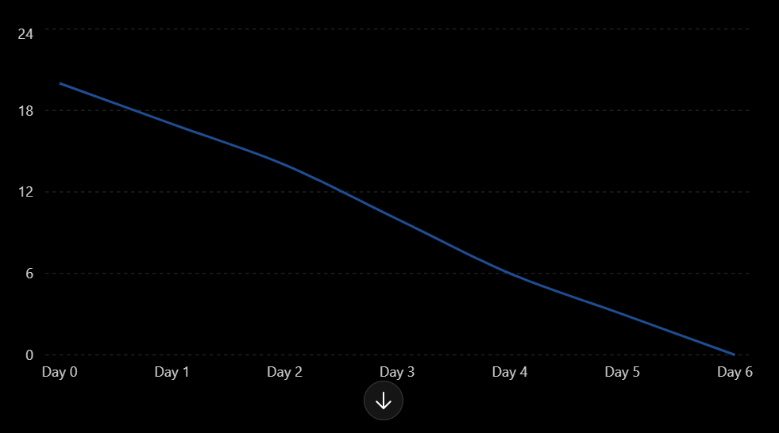
Figure: Sprint Burndown Chart for India's Agricultural Crop Production Analysis

